TC-DISP-016
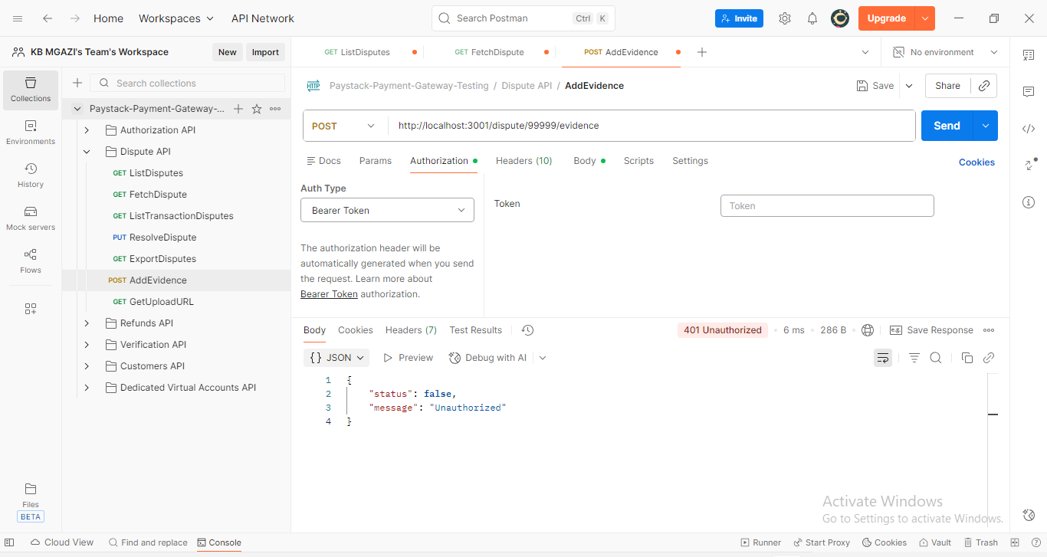
Response:
{
"status": false,
"message": "Unauthorized"
}

